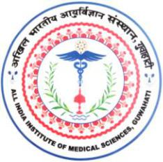**अखिल भारतीय आयुर्विज्ञानसंस्थान(एम्स), गुवाहाटी**

**All India Institute of Medical Sciences, Guwahati**

स्वास्थ्य और पररवार कल्याण मंत्रालय**,**भारत सरकार केतत्वावधान मेंएकवैधाननकननकाय

**(A statutory body under the aegis of Ministry of Health and Family Welfare, GoI)**

**_________________________________________________________________________________________________**

**LEAVE AVAILING/JOINING REPORT**

**Name** **:**

**Designation**

**:**

**Department**

**Nature of leave**

**:**

**:**

**Duration**

**:**

**Commencement of Leave**

**:**

**Date:**

**(Signature of the Applicant)**

**Executive Director/ Dean/ HoD**

**Joined back on duty**

**:**

**Date:**

**(Signature of the Applicant)**

**Executive Director/ Dean/ HoD**